Solution k8s case study

Question 1:

NodeJS is available on port 8888 in the container and will be reaching out to port 27017 for mongo database connection.

MongoDB will be accepting connections on port 27017.

Ans:

Step -1

Mongo service create

---

apiVersion: v1

kind: Service

metadata:

  labels:

    name: mongo

  name: mongo

spec:

  ports:

    - port: 27017

      targetPort: 27017

  selector:

    app: mongo

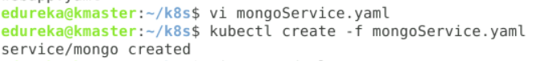

Step 2-

Mongo deployment

---

apiVersion: apps/v1

kind: Deployment

metadata:

  name: mongo_deploy

spec:

  replicas: 1

  selector:

    matchLabels:

      app: mongo

  template:

    metadata:

      name: mongo_pod

      labels:

        app: mongo

    spec:

      containers:

        - name: mongo

          image: mongo

          ports:

            - containerPort: 27001

          volumeMounts:

            - name: mongo

              mountPath: /volume

      volumes:

        - name: mongo

          emptyDir:

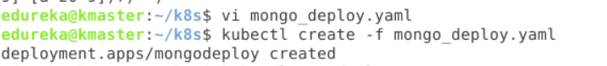

Step 3- node svc

apiVersion: v1

kind: Service

metadata:

  name: nodejs

spec:

  selector:

    app: nodejs

  type: Nodeport

  ports:

    - port: 8888

      targetPort: 8000

      nodePort: 30005

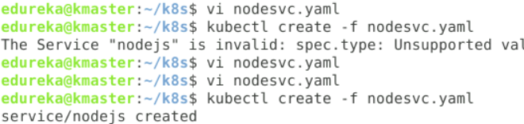

Step 4- node deployment

apiVersion: apps/v1

kind: Deployment

metadata:

  name: nodejs

spec:

  replicas: 1

  selector:

    matchLabels:

      app: nodejs

  template:

    metadata:

      labels:

        app: nodejs

    spec:

      containers:

        - name: nodejs

          image: devopsedu/employee

          ports:

            - ContainerPort: 8888

          env:

            - name: MONGO_URL

              value: mongodb://10.244.1.2:27017/employee



